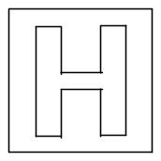

RAFFLES INSTITUTION (JUNIOR COLLEGE)
PRELIMINARY EXAMINATION 2009

HIGHER 2

CHEMISTRY 9746/03

Paper 3 Free Response
16 September 2009

2 hours
Candidates answer on separate paper.

Additional Materials: Writing Papers
Data Booklet

READ THESE INSTRUCTIONS FIRST

DO NOT open this question booklet until you are told to do so.

Write your name, civics tutorial group and index number in the spaces provided on the cover page on page 9 and the writing papers.
Write in dark blue or black pen on both sides of paper.
You may use a soft pencil for any diagrams, graphs or rough working.
Do not use staples, paper clips, highlighters, glue or correction fluid.
Answer any four questions.
Begin each question on a fresh sheet of paper.
A Data Booklet is provided. Do not write anything on it.
You are reminded of the need for good English and clear presentation in your answers.
The number of marks is given in brackets [ ] at the end of each question or part question.
At the end of the examination, fasten all your work securely together, with the cover page on top.

________________________________________________________________________
This question booklet consists of 8 printed pages and one cover page.
Answer any four questions. Begin each question on a fresh sheet of paper.

1 Lactic acid (2-hydroxypropanoic acid), also known as milk acid, is a chemical compound that plays a role in several biochemical processes.

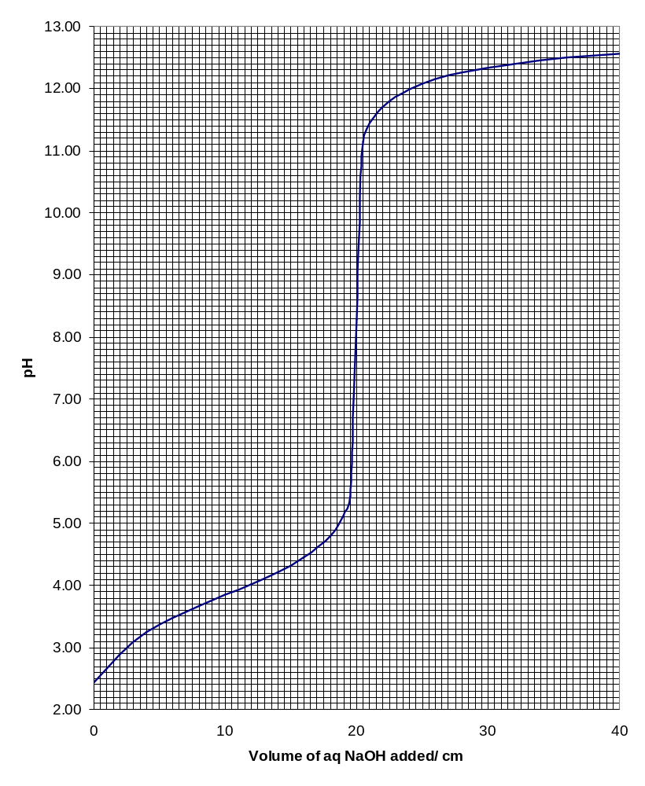
(a) 25.0 cm³ of an aqueous solution of lactic acid is titrated against 0.120 mol dm⁻³ of aqueous sodium hydroxide and the following graph is obtained.

3

(i) Calculate the concentration of the lactic acid used.
(ii) Determine the acid dissociation constant of lactic acid.
- With the aid of an equation, explain why the pH at equivalence point is above 7. [4]

(b) The table below lists some properties of three samples of lactic acid prepared from different natural sources.

Sample | Source | Effect on plane−polarised light | Melting point/ ºC
A | Meat extract | Rotate to the right | 26
B | Fermentation of sucrose | Rotate to the left | 26
C | Sour milk | No effect | 18

(i) With the help of suitable structural formulae, explain why samples A and B behave differently towards plane−polarised light.

(ii) Explain why sample C has no effect on plane−polarised light and suggest why it has a different melting point from A. [4]

(c) When lactic acid is refluxed with a catalytic amount of concentrated sulfuric acid, compound D with the molecular formula of C₆H₈O₄ is formed. It does not react with sodium. Deduce the structural formula of D, giving reasons for your answer. [3]

(d) E is an isomer of lactic acid. It rotates plane-polarised light and reacts with Fehling’s solution to give a reddish brown precipitate. 0.01 mol of E reacts with sodium to give 0.24 dm³ of hydrogen gas under room temperature and pressure conditions.
(i) Suggest a structural formula of E, giving reasons for your answer.

(ii) Explain why E is less acidic than lactic acid. [5]

(e) Maleic acid and fumaric acid are naturally occurring acids found in fruits. They have the same molecular formula of C₄H₄O₄ and are dibasic acids. They both decolourise bromine at room temperature and give the same product upon hydrogenation. Maleic acid has a melting point of 131 ºC while fumaric acid has a melting point of 286 ºC.

(i) Draw the structural formulae of maleic acid and fumaric acid.

(ii) With the help of a suitable diagram, account for the differences in their melting points. [4]

[Total: 20]

2 Cyclobutane is a colourless gas at room temperature. It decomposes to ethene as shown by the following equation:
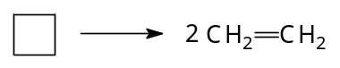
, ΔH₁
(a) To determine ΔH₁, the enthalpy change of reaction of the decomposition of cyclobutane to ethene, the enthalpy change of combustion of cyclobutane is first found by the following experiment:

1.00 g of cyclobutane was completely combusted. The heat evolved increased the temperature of 200 g of water by 46.9 ºC. The heat transfer was known to be only 80% efficient.

(i) Calculate the enthalpy change of combustion of cyclobutane.

(ii) Given that enthalpy change of combustion of ethene is −1422 kJ mol⁻¹ and using your answer in (a)(i), show that ΔH₁ has a value of +99 kJ mol⁻¹.

(iii) Explain briefly why the decomposition of cyclobutane is favoured by a high temperature. [6]

(b) The bond energy of C−C bond in cyclobutane is different from the bond energy of C−C bond in straight chain alkanes.

(i) Define the term bond energy.

(ii) With reference to the Data Booklet and using ΔH₁ = +99 kJ mol⁻¹, calculate the bond energy of C−C bond in cyclobutane.

(iii) Explain why the bond energy of C−C bond in cyclobutane is lower than the bond energy of C−C bond found in the Data Booklet. [5]

(c) Ethene reacts with bromine in tetrachloromethane to form 1,2−dibromoethane as shown by the equation:

CH₂=CH₂ + Br₂ ⎯→ CH₂BrCH₂Br

To find out the orders of reaction with respect to ethene and bromine, ethene and bromine were first dissolved separately in tetrachloromethane. Various volumes of these solutions and tetrachloromethane were mixed and the time taken for the colour of bromine to disappear was recorded. The results are shown in the table below:

Experiment | Volume of ethene solution/ cm³ | Volume of bromine solution/ cm³ | Volume of tetrachloromethane/ cm³ | Time taken for colour of bromine to disappear/ s
1 | 20 | 20 | 0 | 15
2 | 12 | 20 | 8 | 25
3 | 20 | 10 | 10 | 15
4 | 40 | 20 | 20 | t₄

Discuss (i) to (iii) with reference to experiments 1 to 3.

(i) Explain why varying volumes of tetrachloromethane were used.

(ii) State the relationship between the rate of reaction and
    - time taken for the colour of bromine to disappear
    - volume of bromine used

(iii) Deduce the order of reaction with respect to ethene and show that the order of reaction with respect to bromine is 1.

(iv) Suggest a value for t₄, time taken for the colour of bromine to disappear in experiment 4.

(v) When methanol is used as a solvent instead of tetrachloromethane, another product with the formula of C₃H₇OBr is formed. Draw its displayed formula and explain how it is formed. [9]

[Total: 20]

3 Vanadium is a silvery grey metal and forms stable coloured ions of various oxidation state in aqueous solutions:

Formula of ion of vanadium | VO₂⁺ | VO²⁺ | V³⁺ | V²⁺
Colour of ions in aqueous solution | Yellow | Blue | Green | Violet

(a) Explain why aqueous solutions of vanadium ions such as V³⁺ are coloured. [3]

(b) 0.300 g of a vanadium(V) salt is dissolved in water. The aqueous solution formed is then treated with sulfur dioxide gas until reaction is completed. The colour of the reaction mixture changes from yellow to green and finally to blue. The excess sulfur dioxide gas is boiled out. The solution is found to require 33.00 cm³ of 0.0200 mol dm⁻³ acidified aqueous potassium manganate(VII) to convert it back to vanadium(V).

(i) Explain the colour change observed in the reaction between the vanadium(V) salt and sulfur dioxide. Write an equation for the reaction.

(ii) Why must excess sulfur dioxide be completely boiled off before the solution is titrated against potassium manganate(VII) solution?

(iii) Find the percentage by mass of vanadium in the sample. [6]

(c) A new type of rechargeable battery which uses vanadium salts is hailed as a possible battery for electric car. The battery is a flow battery in which the electrolytes are stored in tanks and pumped through the cell during discharge. A diagram of the battery is shown below:
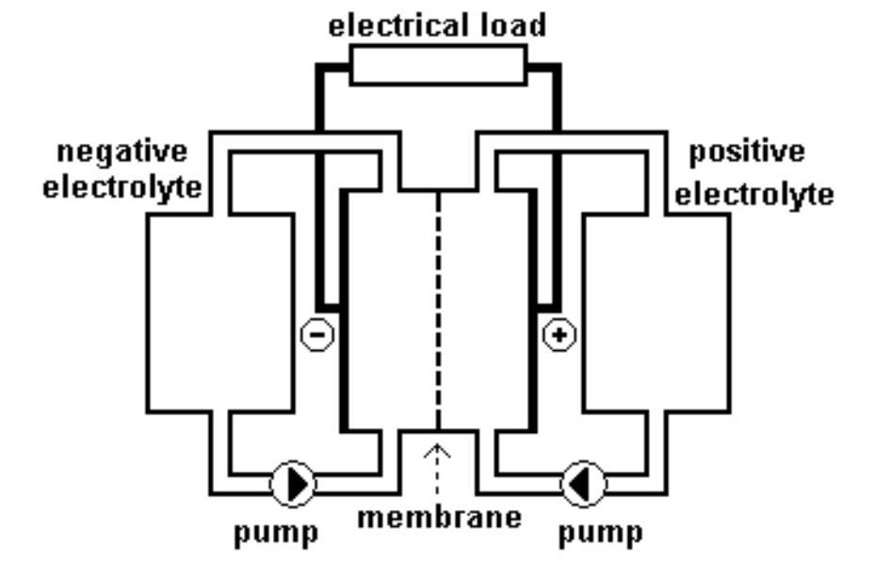
Tank A: Electrolyte containing acidic aqueous solution of sulfate salts of VO₂⁺ and VO²⁺
Tank B: Electrolyte containing acidic aqueous solution of sulfate salts of V³⁺ and V²⁺
Electrode A
Electrode B

The two electrolytes are separated in the cells by an extremely thin membrane that only allows selected ions to flow through. Also in the cells are very stable porous carbon electrodes, where reduction and oxidation reactions take place.

(i) Write equations for the reaction taking place at electrodes A and B and calculate the standard cell potential.

(ii) Is electrode A the positive or negative electrode? Give a reason for your answer.

(iii) Why must the carbon electrodes used be porous?

(iv) The membrane serves to keep the two electrolytes separated. Explain why it needs to allow selected ions to flow through.

(v) Name an advantage that a flow battery has over a conventional battery in which the reactive materials are stored within the cell. [8]

(d) The vanadium redox flow battery in (c) is a rechargeable battery. During recharging, VO²⁺ is converted to VO₂⁺ for electrolyte used in tank A. The total vanadium ion concentration of electrolyte in tank A is 2.00 mol dm⁻³. Find the time (in hours) needed to increase the percentage composition of VO₂⁺ from 10% to 90% for a 3 dm³ electrolyte if a 12 A current is used in the recharging process. [3]

[Total: 20]

4 Halogens and their compounds are important intermediates in many reactions and are used extensively in industries.

(a) With the aid of relevant equations, explain the following statement:
The difference in oxidising power of chlorine and iodine is evident from their reactions with aqueous sodium thiosulfate. [3]

(b) Hydrogen chloride gas may be prepared by reacting sodium chloride with concentrated sulfuric acid.

- Write an equation with state symbols for the reaction between sodium chloride and concentrated sulfuric acid.

- Explain why hydrogen iodide cannot be prepared using sodium iodide and concentrated sulfuric acid.

- Suggest a reagent which may be added to sodium iodide to produce hydrogen iodide. [3]

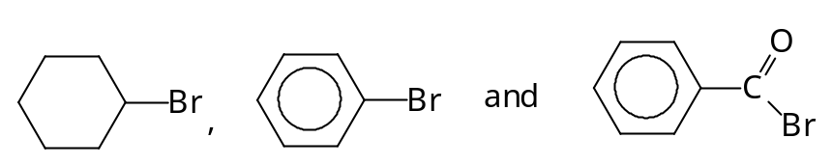
(c) The following compounds differ in their reactivities with aqueous sodium hydroxide:

Describe and explain the differences. [4]

(d) Halogenoalkanes, RX, are important intermediates used to produce many organic compounds. They may be converted into Grignard reagents by reacting them with magnesium in dry ether:
dry ether
RX + Mg ⎯⎯⎯⎯⎯⎯→ R⎯Mg⎯X
δ− 2δ+ δ−
Grignard reagent

RMgX is called an organometallic compound, where R is an alkyl group and X is chlorine, bromine or iodine.

R in RMgX behaves like an anion, R⁻ and is strongly basic and nucleophilic.

(i) Explain why calcium, which is in the same group as magnesium in the Periodic Table, does not form an organometallic compound with halogenoalkane. Suggest an element which gives a similar reaction with halogenoalkane as magnesium.

(ii) Why must the ether, which is used as solvent, be dry?

(iii) The reactivity between halogenoalkanes and Mg is in the order:
iodoalkane > bromoalkane> chloroalkane > fluoroalkane
Explain the trend in reactivity.

On reaction with carbonyl compounds, RMgX forms various classes of alcohols:
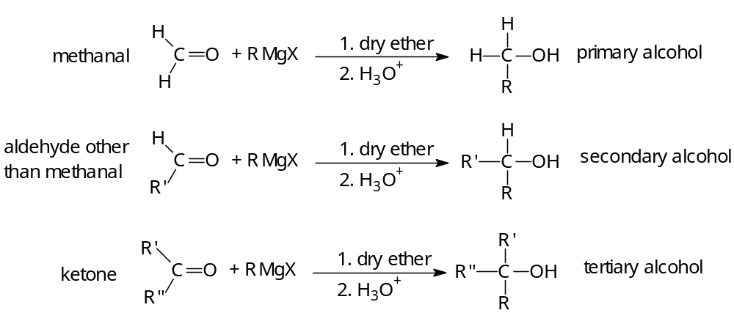

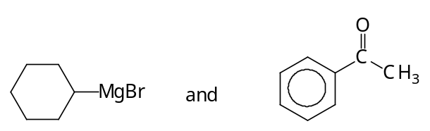
(iv) Draw the structure of the organic product formed when the following are reacted:

(v) Give the displayed formula of the bromoalkane which can be used to form a Grignard reagent that would react with butanal to give 2−methylhexan−3−ol.

(vi) When RMgBr is reacted with ethanoyl bromide, 2 mol of RMgBr are required per mol of ethanoyl bromide and the product formed is CH₃CR₂OH.

Suggest why one mol of ethanoyl bromide reacts with two mol of RMgBr while one mol of aldehyde or ketone reacts with one mol of RMgBr.
(vii) When CH₃MgBr and CH₃CH₂MgBr are reacted with methanoyl bromide, HCOBr, the following alcohols are formed:
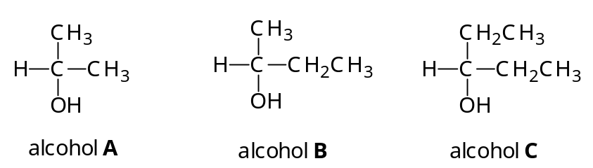
Find the ratio for amount of alcohols A, B and C formed if the ratio of CH₃MgBr to CH₃CH₂MgBr used is 2:1. [10]

[Total: 20]

5 Nitrogen containing compounds are important in many biochemical processes. Their physical properties and reactions depend on their structures.

(a) The structures of three isomers are shown below:
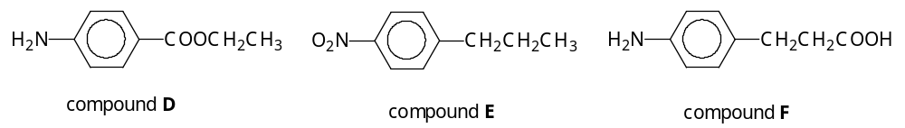

(i) With appropriate structures and equations, explain why the melting point and solubility in aqueous sodium hydroxide are lower for compound D compared to compound F.

(ii) Construct a 3−step reaction scheme to show how D may be synthesised from E, showing reagents and conditions used clearly.

(iii) Draw the structure of an isomer of D which gives a yellow precipitate when warmed with aqueous alkaline iodine and is insoluble in both aqueous sodium carbonate and dilute hydrochloric acid. [11]

(b) Compound G with a molecular formula of C₈H₁₁O₃N is a neurotransmitter. It rotates plane−polarised light and gives a violet colouration with neutral iron(III) chloride solution. G is insoluble in water but dissolves in dilute sulfuric acid. One mol of G reacts with 2 mol of aqueous sodium hydroxide to form a soluble product. G reacts with hot acidified potassium dichromate(VI) to give a product which reacts with 2,4−dinitrophenylhydrazine to give an orange precipitate.

When warmed with aluminium oxide, G forms compound H, C₈H₉O₂N. H reacts with aqueous bromine to form a compound with molecular formula C₈H₇O₃NBr₄.

When G is reacted with ethanedioyl chloride, CCO−COC, compound J, C₁₂H₇O₇N is formed. It has 3 hexagonal rings in its structure and is insoluble in both dilute acid and alkali.

Deduce structures for compounds G, H and J, explaining the reactions involved. [9]

[Total 20]
☺☺☺☺☺ End of Paper ☺☺☺☺☺
COVER PAGE
Name: | Index No: | CT Group:

RAFFLES INSTITUTION (JUNIOR COLLEGE)
PRELIMINARY EXAMINATION 2009

HIGHER 2
CHEMISTRY 9746
Attach this cover page to the top of your answer scripts.
Question  (Please circle the questions you have attempted.) | For Examiners’ Use Only  Parts |  |  |  |  |  |  |  |  |  |  | Marks
1 | (a) | (b) |  |  | (c) |  |  | (d) |  |  | (e) | / 20
2 | (a) |  |  | (b) |  |  |  |  | (c) |  |  | / 20
3 | (a) |  | (b) |  |  |  | (c) |  |  | (d) |  | / 20
4 | (a) |  | (b) |  |  |  | (c) |  |  | (d) |  | / 20
5 | (a) |  |  |  |  |  | (b) |  |  |  |  | / 20
 |  |  |  |  |  | Paper 1 |  |  |  |  |  | / 40
 |  |  |  |  |  | Paper 2 |  |  |  |  |  | / 60
 |  |  |  |  |  | Paper 3 |  |  |  |  |  | / 80
 |  |  |  |  |  | Total Marks |  |  |  |  |  | /180
 |  |  |  |  |  | Percentage |  |  |  |  |  | %
 |  |  |  |  |  | Grade

